Pareto Distribution:

Any distribution that follows the power law is called Pareto distribution.

It is a non – Gaussian distribution.

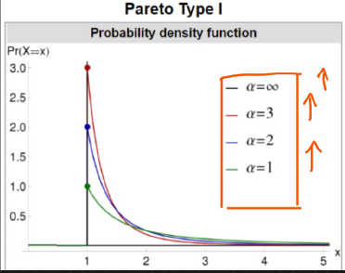

As the value of $α$ increases, the height of the probability density function also increases.

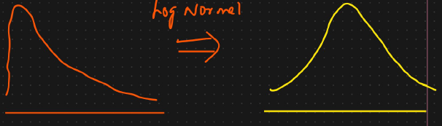



Log normal distribution -> Normal Distribution

Similarly,

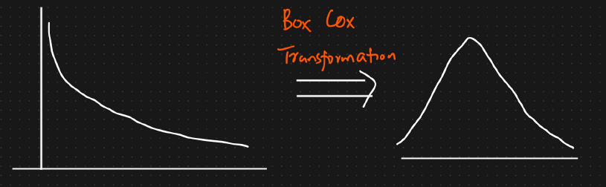

Examples:

80% of the entire project is done by 20% of the team.

80% of the defects can be solved if we solve 20% of the defects.